Readme – Loading and using the ARMS models
Last updated 12/02/2021.
The included models are compatible with OpenSim 4.3.
We suggest the use of Notepad++ for viewing or editing of .xml and .osim files.
Prior to loading the ARMS models in OpenSim 4.3, make sure OpenSim 4.3 can reference the geometry files.
- To do this, go to edit->preferences… on the OpenSim toolbar
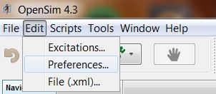
- In the Preferences window, update the value to where the included Geometry file is located
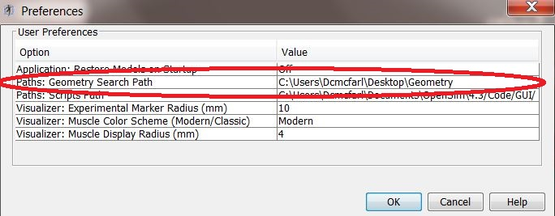
If you skip these previous steps, OpenSim will not be able to find the geometry .vtp files and the model bones will appear malaligned or are absent. You will also receive an error in the message window when the model is loaded, see below.
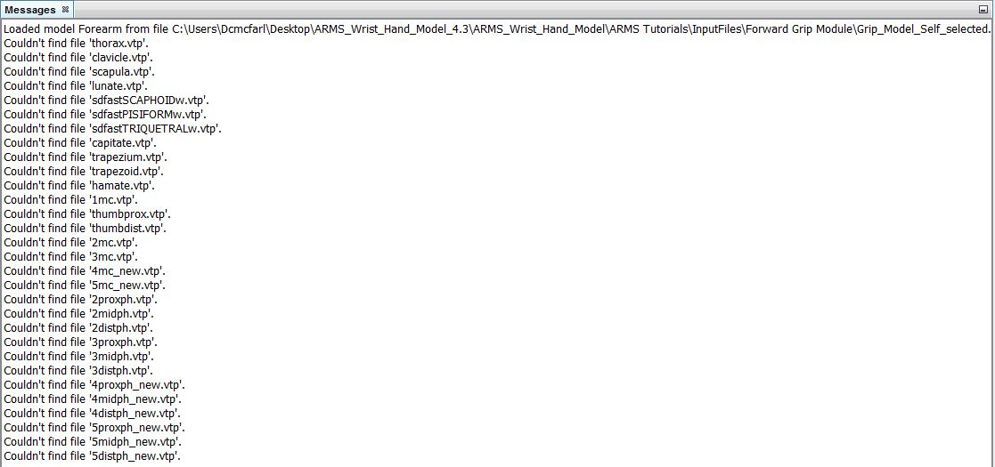

Example of misaligned bone geometry for the ARMS Grip_Model.osim:
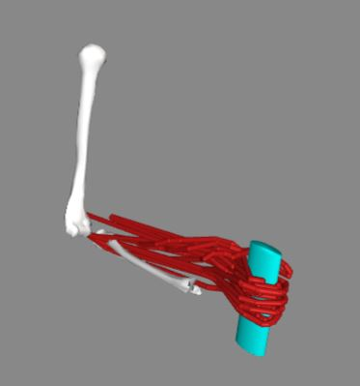
Example of correct visualization for the ARMS Grip_Model.osim:
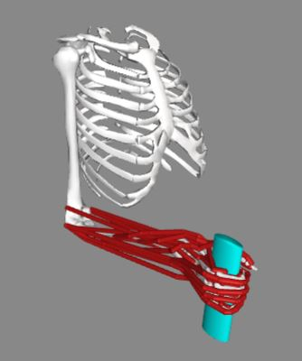

Make sure to turn off the floor in the OpenSim Visualizer
- To do this, click on Open View Controls in the top right of the visualizer window
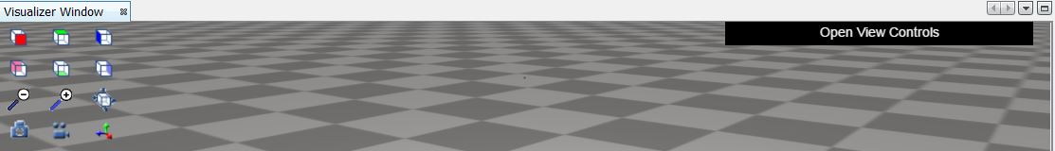
- In the drop-down menu, set the floor texture to nofloor
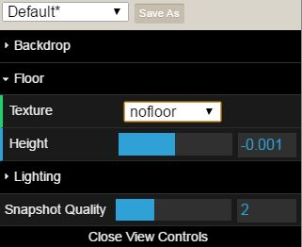
When the floor is on, you will only be able to see the top of the torso and humerus bone geometries.
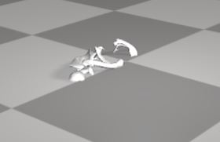
Changing the muscle display radius:
- By default, the muscle display radius in OpenSim 4.3 is large (8mm). This value does not affect simulation results, but can make it difficult to visualize individual muscle paths. We recommend using a smaller value (2mm)
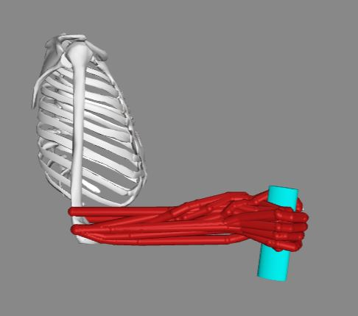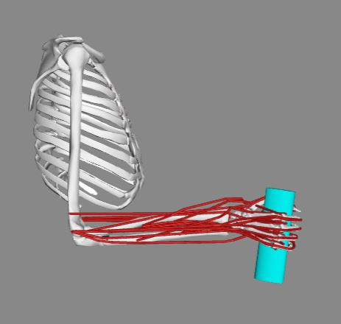
Display radius (8mm) Display radius (2mm)

- To change the display radius, go to edit->preferences… on the OpenSim toolbar
- In the Preferences window, update the value to desired display radius. You will need to re-load the model for the changes to take affect.
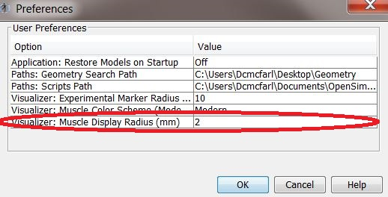
Running Simulations:
- While a simulation is running in OpenSim, the bottom right hand corner will display the simulation progress.
- When the progress bar reaches 100% and disappears, the simulation has completed. The message window will display a message saying it is printing the results of the investigation

- After the simulation has ran, you can view the motion in the visualizer.

When viewing the results of Module 2 in the visualizer, the motion will freeze around 4.7 seconds. This is an issue with the visualizer displaying the motion and not the actual simulation result. We are working with the OpenSim team to resolve this issue. When developing your own simulations, it is possible that you may also encounter this issue with the visualizer as well.
Other important things to know:
- For each simulation module, there are different models that are derivatives of the Hand_Wrist_Model_for_development.osim in the main folder.
- The Grip_models do not include the intrinsic thumb muscles, but also includes contact surfaces over the phalanges.
- The Pinch_model only includes DOFs for thumb and wrist, does not include the extrinsic and intrinsic finger muscles, and includes a point constraint at the thumbtip
- The Tenodesis_model includes prescribed wrist flexion
- The Hand_wrist_model in the input file folder does not include the coordinatelimitforces for wrist flexion and deviation (see paper for reason).

- All degrees of freedom listed in the coordinates tab are in degrees except for the wrist degrees of freedom (deviation and flexion). Deviation and flexion are in radians.
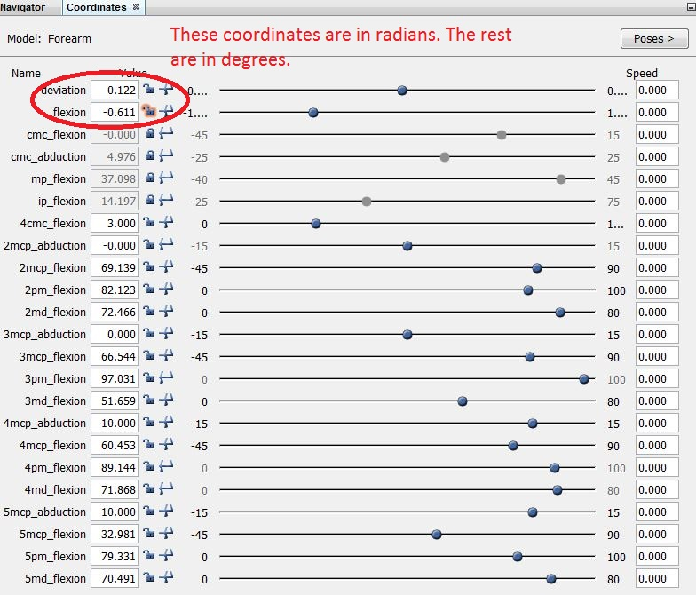

- The Grip_Model.osim needs the 13 .OBJ files that define the contact surfaces to be in the same folder as the .osim model. You will receive the following error message if they are not in the same folder:
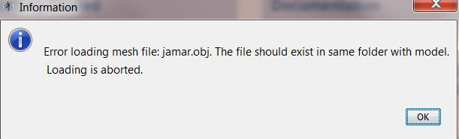

- To set up scripting with MATLAB using the OpenSim API follow the instructions in the link below:
https://simtk-confluence.stanford.edu:8443/display/OpenSim/Scripting+with+Matlab

For more details on Forward Dynamics and static optimization with OpenSim see the following webpages:
https://simtk-confluence.stanford.edu:8443/display/OpenSim/Getting+Started+with+Forward+Dynamics
https://simtk-confluence.stanford.edu:8443/display/OpenSim/Getting+Started+with+Static+Optimization
Details on using Joint Reaction Analysis:
https://simtk-confluence.stanford.edu:8443/display/OpenSim/Joint+Reactions+Analysis
Details on using OpenSim Plot
https://simtk-confluence.stanford.edu:8443/display/OpenSim/Plotting

